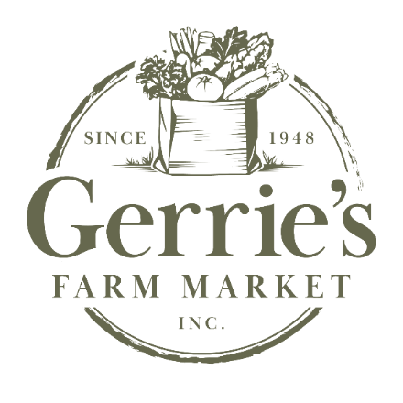

7646 Colborne St.
Elora ON N0B 1S0
Phone (519) 846-9639
Fax (226) 384-6037
info@gerriesfarmmarket.ca

STRAWBERRY PLANTS

EARLY SEASON
Annapolis Med-large, pale red, firm, sweet, berries. Moderate yield.
AC Wendy Med-large, sweet, bright coloured berries, vigorous plant.
AC Audrey ** Good size, deep red, shiny berries.
Galletta Large size, shiny berries, very productive and hardy.
Sable Med-large, bright red, juicy, excellent flavour. Moderately firm.

MID-SEASON
Honeoye Medium, firm, glossy fruit, high yields, tends to have white tips.
Brunswick Large, uniform, firm, shiny berries with good flavour. High yield.
Cavendish Large, firm, high yielding, sweet berry, good for freezing.

Laurel Large, hardy, with heavy yields.

Kent Medium, sweet, dark red fruit. High yields, long season.
Jewel Med-large, bright glossy fruit, does well on light soil, less hardy.

Cabot Very large, bright red, good hardiness and productivity.
AC Evelyn ** Very large, flavourful fruit, hardy and productive.

LATE SEASON
AAC Kate ** Very large, firm, bright red, mid-late, excellent yields.
AC St Laurent ** Large, very productive, good flavour.
AC Valley Sunset ** Large, bright red, mild, sweet, soft skinned fruit.
Malwina Large, very late, glossy dark red, vigorous plant.
.

DAY NEUTRAL
Seascape Large, good flavour and yield.

AC is an official trademark used to a license granted by Agriculture and Agrifood Canada.

** Royalty fee (extra fee over the listed price, goes back to the producer)

Prices on the other side
Variety | 100-400 | 500-900 | 1000-4900 | 5000+ (total order)
Most Varieties (except those below) | $48.00/100 | $36.00/100 | $280.00/1000 | $260.00/1000
AC Audrey, Galletta, AC Evelyn, AAC Kate, AC St Laurent | $52.00/100 | $41.00/100 | $320.00/1000 | $305.00/1000
Malwina | $67.00/100 | $54.00/100 | $425.00/1000
Day Neutral | $73.00/100 | $60.00/100 | $450.00/1000

STRAWBERRY PRICES

**Royalty fees
AC Audrey, AC Valley Sunset, AC St-Laurent $12.00/1000
AC Evelyn, AAC Kate, $17.00/1000

Order Minimum for delivery - 2000 plants
Minimum strawberries 100 plants/variety. Order in increments of 100. Minimum raspberries 10 plants/variety. Order in increments of 10 or 25.
Any amount can be picked up at our retail location.

RASPBERRY PLANTS
Prelude Red, early, large and firm berry, cold hardy, and very productive.
Boyne Red, early, medium-large, hardy, good yield, heritage variety.
Eden** Red, early-mid, firm, large, excellent flavor. Royalty 20% over list price
Nova Red, medium size, mild flavour, less thorny cane..
K-81-6. Red, late, large and sweet berry, very hardy plant.
Royalty Purple, late, large, very mild taste, vigorous plant.
Jewel Black, large, mild sweet flavour, less hardy.
Anne Golden Yellow, sweet, large , firm berries, unique addition to any garden.

Pathfinder August bearing, med-large, sweet, flavourful berries, short canes.
Polana Fall bearing, Large, light red, firm fruit, produces well until after frost.
Heritage Everbearing, medium, firm, hardy.

Variety | 10 | 25 | 50 | 100
Boyne, Eden, Nova,  K-81-6, Royalty, Heritage. | $38.00 | $72.00 | $128.00 | $225.00
Prelude, Pathfinder, Polana, Jewel | $41.00 | $89.00 | $160.00 | $288.00
Anne $6.25 each | $55.00 | $118.75

